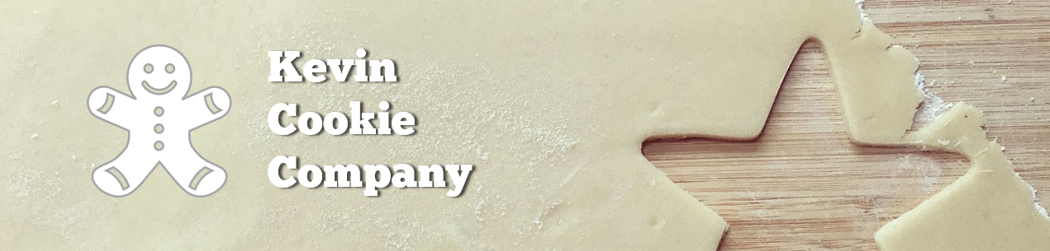

Cookie Order Form

|  |  |  |
| --- | --- | --- |
| Order Number: | 12846 | |
| Your Full Name: | Megan Dickens | |
| Cookie Type & Quantity: | Chocolate Chip | 20 |
| How did you hear about us? | Superbowl Commercial | |
| Preferred Delivery Method: | Drone | |
| Desired Delivery Date: | 2/13/2021 | |

We appreciate your business!